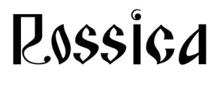
ROSSICA - 2022


– 7-11 October, 2022

A.S. Popov-Museum at Sankt-Petersburg

FOR OFFICIAL USE ONLY

Entry Number Frame Numbers Number of Frames allotted Remarks

Application Form
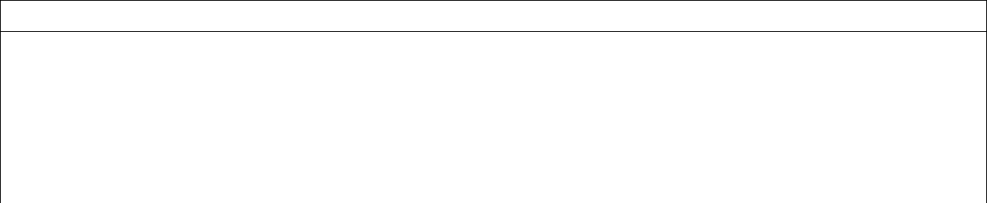

Notes
- Fill in a separate form for each exhibit.

- Please type or print.
- Completed form must be sent to:

The Commissioner General, ROSSICA – 2022
Andrey Strygin |  |  | by e-mail: strygin@inbox.ru
before 01.07.2022
Mr. □Mrs. □ | Miss. □ | Surname (family name) | First Name
Address |  |  | Postcode
 |  |  | Country
Telephone: |  | Fax: | e-mail:
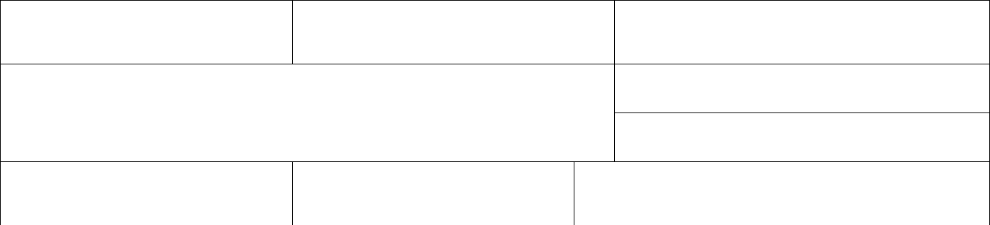

Membership of a Philatelic Academy (please, specify)

Title of the exhibit

Short Description of the Exhibit
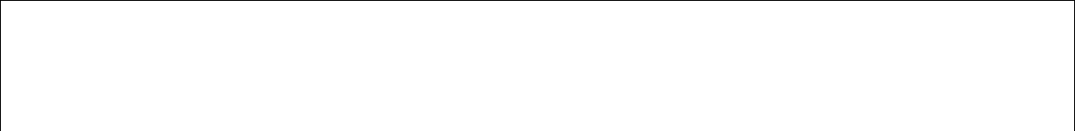

Exhibit class (in according to GREX) | Number of Frames requested
Past Awards at FIP or Continental | Exhibition Name (s) | LGGLVV
Exhibitions recognized by FIP
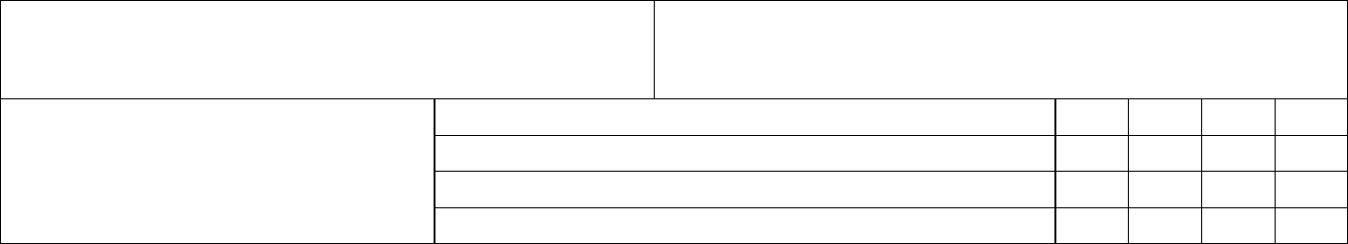

I, the undersigned, declare to have taken knowledge of and I agree to the special regulations of the ROSSICA – 2022.

Place, date and signature:________________________________________________________________

